Financial Engineering Lab 5

Question 1
Index - BSE SENSEX
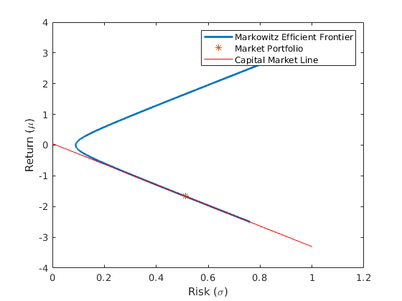
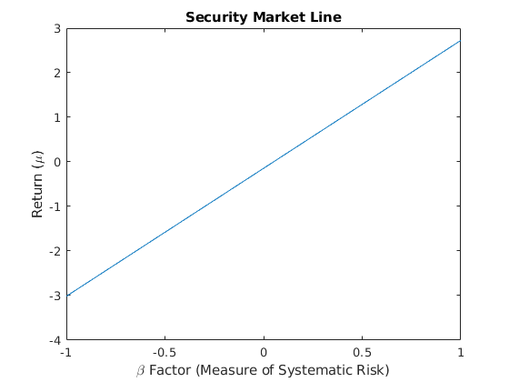

Betas for stocks included in the Index
Stock Name Beta
BHARTIARTL 0.337644
HDFCBANK 3.541285
HINDUNLVR 2.191615
ITC 0.481387
KOTKBANK 3.597511
MARUTI 5.776251
NESTLEIND 0.717518
RELIANCE 1.839009
SBIN 1.390641
TCS 0.620572
Betas for stocks not included in the Index
Stock Name Beta
ASHOKLEY 11.160214
BHEL 0.092191
BOSCHLTD 2.820069
CROMPTON 6.677576
MRF 4.269269
PETRONET 4.956774
PIDILITE 4.017999
SIEMENS 2.111086
TATAGLOBAL 0.236892
TVSMOTOR 11.296673

Index - NSE NIFTY50
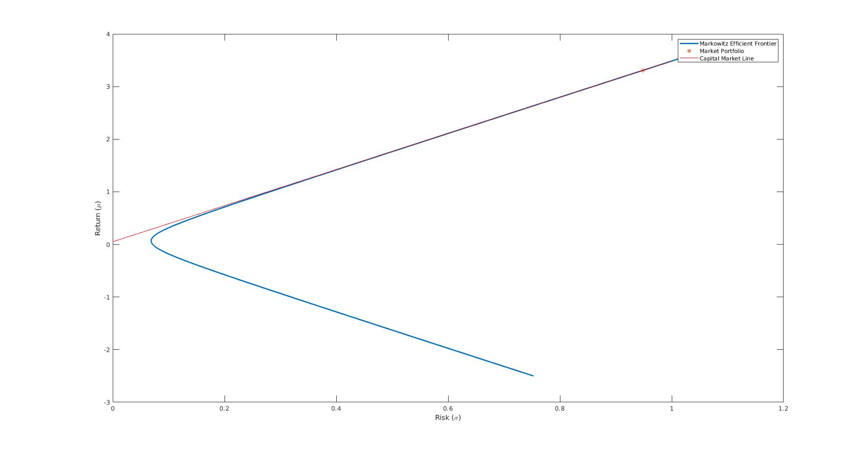

Betas for stocks included in the Index
Stock Name Beta
HDFCBANK 2.642570
HINDUNLVR 1.983424
INFY 0.335879
ITC 0.369266
KOTAKBANK 3.270685
MARUTI 5.252674
NESTLEIND 0.643459
RELIANCE 1.335139
SBIN 1.261165
TCS 0.359094
Betas for stocks not included in the Index
Stock Name Beta
ASHOKLEY 10.157448
BOSCHLTD 2.570322
DLF -0.084197
HAVELLS 3.645767
IDEA -0.878031
L_TFH 1.176804
NHPC 0.666085
JUSTDIAL -1.407088
NIITECH 1.187624
SIEMENS 1.912684

Beta is a measure of a stock's volatility in relation to the market. By definition, the market has a beta of 1.0, and individual stocks are ranked according to how much they deviate from the market. A stock that swings more than the market over time has a beta above 1.0. If a stock moves less than the market, the stock's beta is less than 1.0. High-beta stocks are supposed to be riskier but provide a potential for higher returns; low-beta stocks pose less risk but also lower returns.

